What are interfaces

* An interface is a collection of abstract methods and final variables.
* **Syntax:**

interfaceInterfaceName {

// abstract methods

// constant variables

}

* **Example:**

interface Stack {

void push (int item );// default public and abstract

int pop(); // default public and abstract

int MAX = 3; // default public static and abstract

}

* Each method in an interface is also implicitly abstract, so the abstract keyword is not needed.
* Methods in an interface are interface are implicitly public.
  1. **Implementing an interface**
* One or more class can implement interface.
* Class that implement interface must provide definition to all abstract methods of that interface.
* Two ways of implementing interface

1. Class *implements* interface
2. Class *extends* class and *implements* interface

Class implements interface

classClassName***implements***interfaceName {

//implement abstract methods of interface

// other stuff

}

Class extends class and implements interface

classClassName***extends***SuperClass***implements***interfaceName {

//implement abstract methods of interface

// other stuff

}

Interface Shape {

double area ( double length, double breadth);

static final String color = “Red”;

}

class Rectangle implements Shape {

public double area (double length, double breadth ) {

return (height * breadth);

}

public static void main(String [] a) {

Rectangle rect = new Rectangle( );

doubleareaRect = rect.area() ;

System.out.println( “Area =” + areaRect );

}

}

* 1. **Implementing multiple interface**

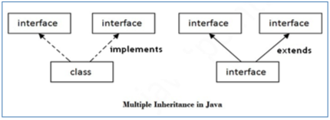

* Multiple inheritance can be archive only through the interfaces
* **class implements multiple interface**
* A class can implement more than one interface at a time.
* Syntax

class ClassName **implements** *interface1*, *interface2* {

//code

}

* Write Simple Program on Java for the implementation of Multiple inheritance using interfaces to calculate the area of a rectangle and triangle

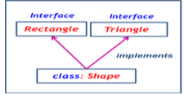

Example :

interface Rectangle {

public void areaRectangle(double width, double height);

}

interface Triangle {

public void areaTriangle (double base, double height);

}

class Shape **implements** Rectangle, Triangle {

public void areaRectangle (double width , double height ) {

double area = width * height ;

System.out.println ("The Area of Rectangle is " + area);

}

public void areaTriangle (double base, double height) {

double area = (0.5 * base * height);

System.out.println ("The Area of Triangle is " + area); }

}

public class MultiInheritance {

public static void main (String args[]) {

Shape sh = new Shape();

sh.areaRectangle(10.00, 5.00);

sh.areaTriangle(8.5, 4.5);

}

}